# **Aaron Myers Video Transcript**

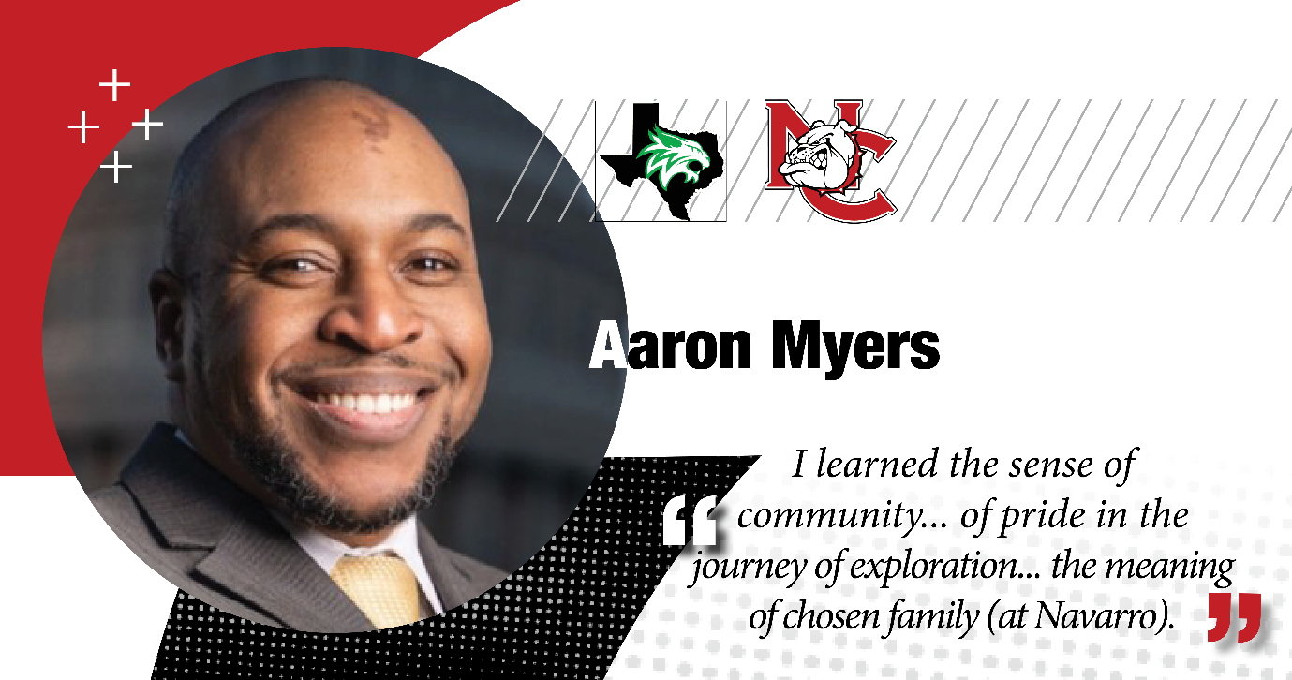

**Aaron Myers:** Uh, when I think about, uh, Navarro College, uh, who I would not be who I am today without Navarro College. It gave me the ability to wish, uh, to meet new people and to, from an academic standpoint, have a passport to the world to be introduced to people of different beliefs and ideologies.

Thank you to Dr. Linda Davis and Dr. Rah-Lauren Robertstadt and Dr. O'Neill and Dr. Stringer. Uh, which I may wish I might 20 years ago. And everyone should have a piece in Navarro in their life. Thank you! Proud Bulldog.