# **Amanda Glassburner Video Transcript**

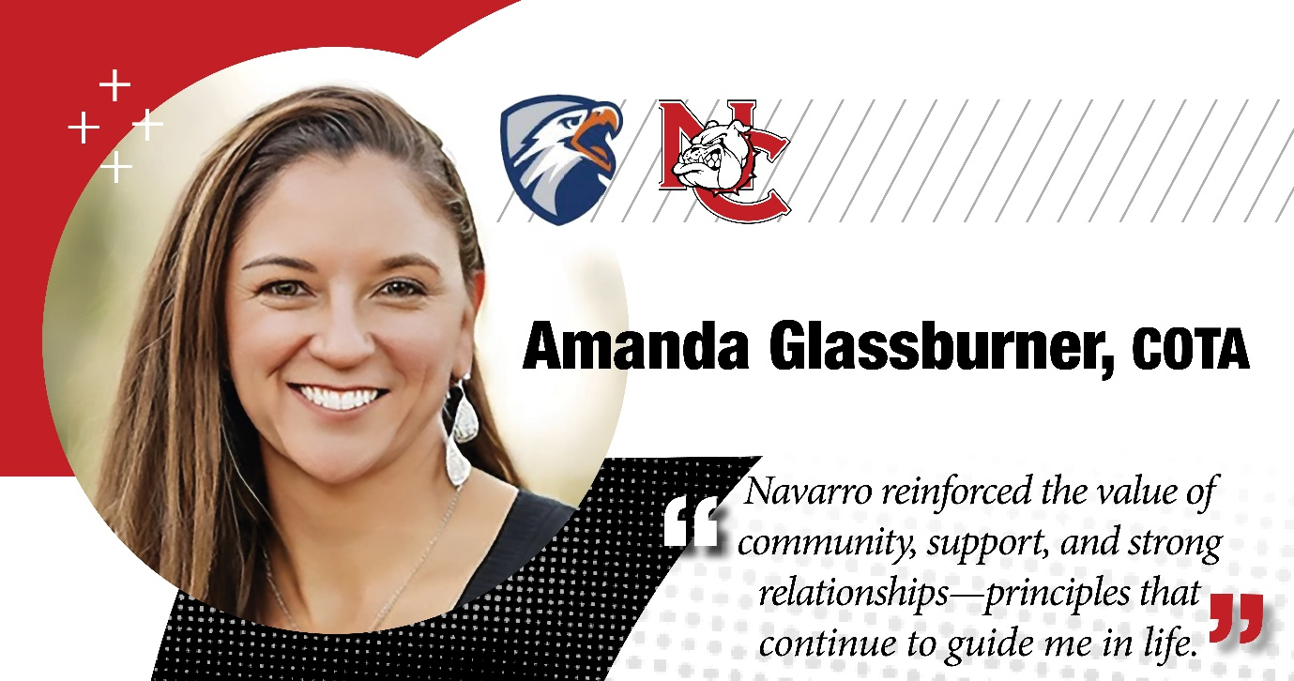

**Amanda Glassburner:** I'm a Certified Occupational Therapist Assistant. I'm an entrepreneur, creator and founder of Therapy Busy Box, and a Navarro College graduate.

It changed the way I thought about occupational therapy. Um, some of my patients even said thank you. Whereas kids, (laugh) they don't necessarily, you know. But I, I just was, had they not put me in that specific hospital, um, I would have never known.

Um, I would have never, I would have never known, uh, that side of occupational therapy because it absolutely was not what I was gearing my brain towards. And it just was a paradigm shift for me. And I, you got to see so many changes physically.

I have literally watched the miracles every day in that building. I watched people walk or wheel in, you know, and, and not even being able to sit up at the edge of the bed and we can get them to where they're standing and walking, you know, I mean, it's just it's the neatest thing.

So, so, um, the more they work, the better they get and so I would leave little homework boxes in their room, nothing like this, but it was something of the sort.

And when, when it came time for patients to leave, the family members would always, would always say, “Well, how do I get something like this?” And there was never one product that I could refer them to. Um, so I would send them to Walmart to get some clothes pins and send them Hobby Lobby to get beads, but you only need 20 of the beads, you don’t need 200 but you’re to buy a bag of 200, you know?

So, um, fast forward, you know, in 2020 when COVID started hitting 2019 and into 2020, I started looking online. I thought, “I wonder if anybody's done this yet?” And I started looking and nobody had. There was plenty of like sensory boxes and things like that, but there was nothing that was therapeutically driven and guided. So, I was able to just kind of brain dump and at that time, I guess, put about 15 years’ worth of fine motor exercise sizes and things like that together into a manual, found the right packaging, and then was able to launch in March of 2020.