# **Canice Eshiebor Video Transcript**

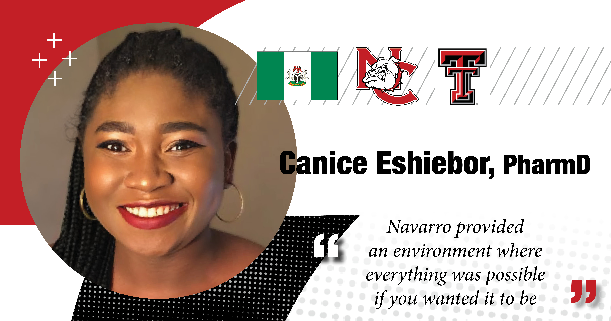  
  
**Canice:** Like I said, personally, just being around the professors, each and every one of them were helpful to me. And so just having that group, having people that believe they all, you know, when you come up and you said you tell your advice to this is what I want, this is what I want to do.

They're all there to set you there and set you to where you want to be. You know, they're there to support you to get there. So the Navarro, like I said, was my first stomping ground.

Navarro taught me that whatever I set my mind to, I could do it from like a set from juggling Organic Chemistry 1 semester and taking Microbiology and being all in one.

So it's, it was a lot. But just having that support system and having people that believe in you, that know that this is, they're more than just doing their job, you know.

(Dr. Mark Haney, Navarro College Chemistry Professor)

**Dr. Mark Haney:** So I do remember Canice Eshiebor as my student.

Canice Eshiebor is a very gregarious student and in fact, I don't think any professor that got to know Canice Eshiebor could ever forget Canice Eshiebor because she gets along so well with the other students and she got along well with me.

She's a very studious person and she applied herself to studies, but she also took my guidance.

There were times that I needed to say you need to go in this direction with your studies and focus on this because that's what you need to propel yourself in pharmacology.

And God bless her; she took that advice and I'll say now she's got her PhD in pharmacology and has been very successful.