**Madison Thompson Video Transcript**

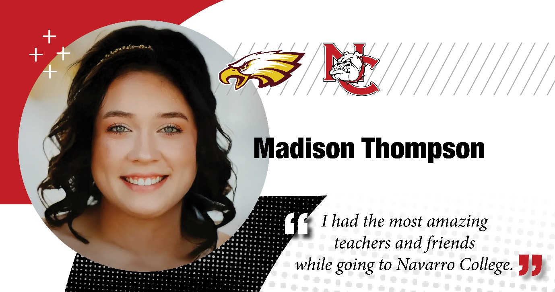

**Madison Thompson:** Hi, my name is Madison Thompson. I'm a recent 2024 Navarro Cosmetology graduate.

I am so grateful for my time at Navarro. It has truly set me up for success in the long run. I get told all the time that it is so rare to find somebody that knows so much coming straight out of school and that is all thanks to Navarro.

Thank you to all my teachers. I have grown my clientele so fast since graduating. It is literally insane, but, um, thank you to all my teachers. I could not have done it without you.

Thank you, Navarro College for featuring me in this video and Go Bulldogs.