# **Nancy Chaney Video Transcript**

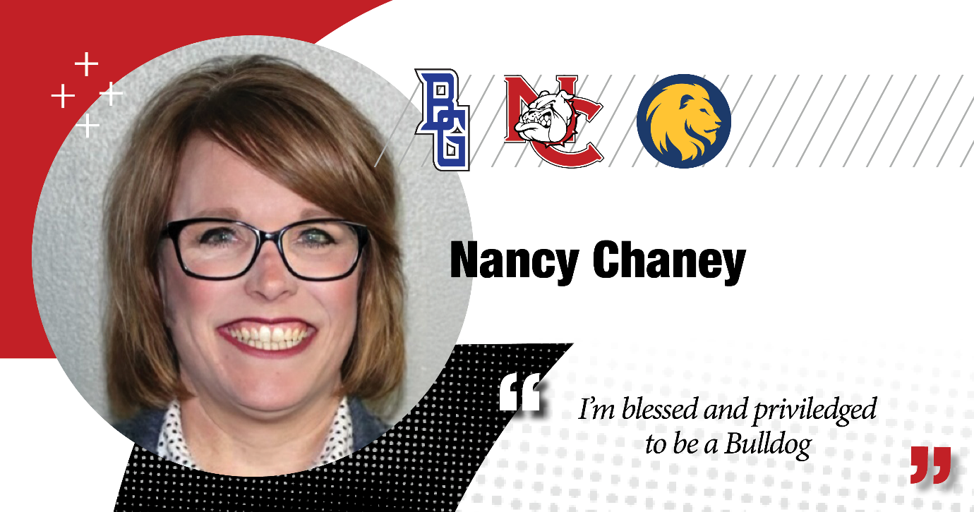

**Nancy Chaney:** I'm Nancy Chaney. Not only am I alumni with Navarro College, I'm also an employee at Navarro College.

My educational journey started back in 1992, taking just a few classes at a time and working full-time.

Eventually, in 2000, received my Associates of Applied Science and Paralegal Studies.

I really wanted to be an employee of Navarro College. I so did that. But working at Navarro College, I was very interested in obtaining my bachelor's. So, I did what I needed to do, to head over to our university partner at Texas A&M Commerce and received my Bachelors of Applied Arts and Science in the year 2017.

So, I've been blessed to be an employee here for 17 years. Yay! Go, Bulldogs! And I've enjoyed it. And I'm proud and privileged to say that I am a Bulldog.

So along with my educational journey here and my employment today, 17 years later, I am the District Coordinator of Tutoring and Student Support programming.

Just recently, in the spring of 2025, I am an adjunct professor of Paralegal Studies. So, I'm blessed and privileged to be a Bulldog and being part of the Navarro College family.