**Teri Stewart Video Transcript**

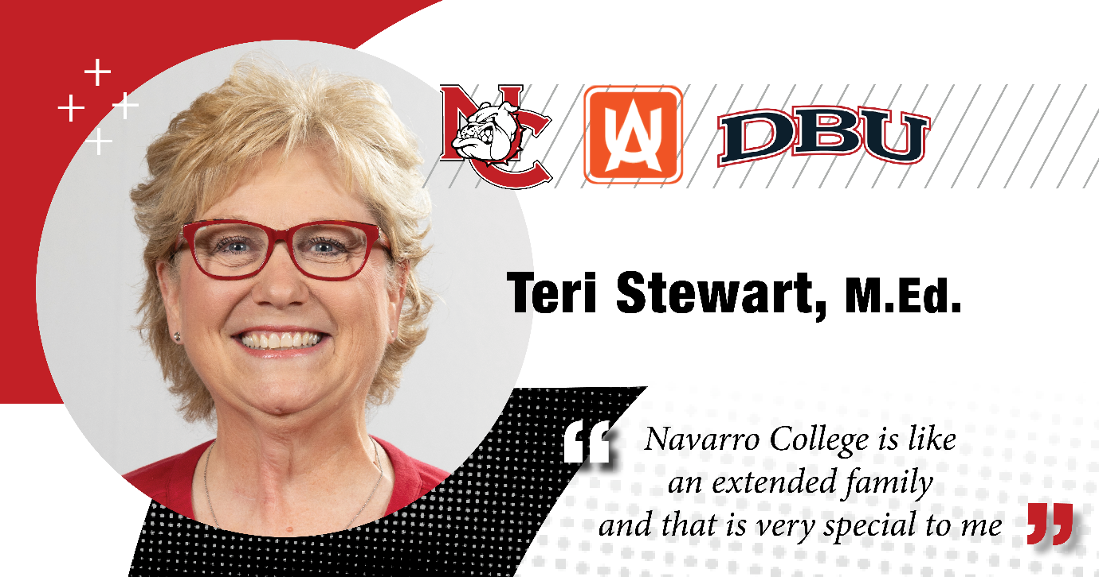

**Screen Text:** How has NC impacted you?

**Teri Stewart:** We have a little saying at my house, if Teri's not talking about God, she's talking about Navarro College, and that is the truth. I love Navarro College, not just coming to school here, but being a part of the work family. I believe I'm actually part of a family here at the community college here at Navarro College.

So, I encourage anybody, if you have thought about coming back to school or you need a career change or you need a job, Navarro College is the place to be.

My name is Teri Stewart and I am a proud Navarro College Bulldog. If I can do it, you can do it.